Name ____________________
Geometry Honors
Chapter 5 Review Handout

Please leave all answers in exact simplest form.

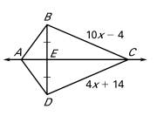
Use the diagram when $\overline{AE}$ is the perpendicular bisector of ∆ABD and ΔBCD is isosceles.
111
8
19

1. Find BD
2. Find AB
3. Find BC
19

The perpendicular bisectors of ΔABC meet at point D.
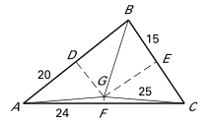
4. Find AG
5. Find BC
6. Find BG

Complete the statement with the always, sometimes or never.

7. The perpendicular bisectors of a triangle will __________________ intersect on the triangle.

8. The perimeter of the triangle formed by the midsegments is ________________ half of the original triangle’s perimeter.

9. The medians will _________________ intersect inside an acute triangle.

10. The perpendicular bisectors of an acute triangle will _________________ intersect on the triangle.

11. Obtuse triangle medians will ____________ intersect on the triangle.

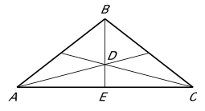
Use the diagram given D is the centroid of ∆ABC.
6
12
7.5

12. Find BC

13. Find BE

14. Find DE

15. Find the perimeter of ∆ABC

Solve for x.
16. $\overline{BD}$ is the median of ∆ABC. 17. $\overline{AD}$ is the perpendicular bisector of ∆ABC.
C
B
A
(2x-4)°
A
B
C
2x+4
3x-5
x+11
D

18. In ∆SAM, $\overline{AT}$ is the median. If ST = 5x – 4, TM = x + 8, and AM = 7x – 13, find AM.

19. In ∆TOM, $\overline{ON}$ is an altitude, if m<ONT – 7x + 6, TN = 2x – 5, and NM = x – 6, find TM if N is between T and M.

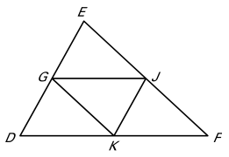
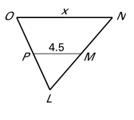
20. Find the value of x. 21. Find the value of x if the perimeter of ΔEDF is 50 units.

2x+2
x+2
4x
2x-6
¹/₃x+3

22. In ∆GEO, M is the midpoint of $\overline{GE}$, T is the midpoint of $\overline{EO}$ and GO = 15. Find MT.

23. The lengths of two sides of a triangle are 8, and 9. Find the range of possible lengths for the third side.

24. The sides of a triangle are represented by x+6, 3x-2, and 12. Find the range of the values for x.
25. State the order of the sides of the 26. State the order of the angles of the
triangle from smallest to largest. triangle from smallest to largest
7
8
12
A
B
C
50°
110°

27. Can these lengths represent the sides of a triangle? 6, 12, and 15

Complete the statement by writing <, =, or >.
28. TP ____ AG 29. m<1 ____ m<2
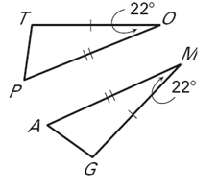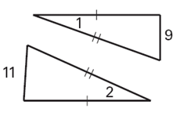

30. AT ____ BT 31. m<1 ____ m<2
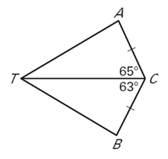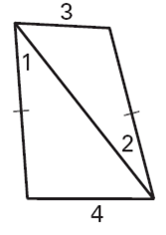
32. Find the missing coordinates without using any new variables.
B (___, ___)
A (0,a)
C(___, ___)

D(0, -b)
A. B.

33. Use a coordinate proof to prove the diagonals of an isosceles trapezoid are congruent.
P(-a,0)

R(b,c)
Q (-b,c)
S(a,0)
B (___, ___)
A (a,b)

