Extra Credit:
Mrs. Ortiz wants to know if @UberFacts is full of crap or not! This was tweeted yesterday...

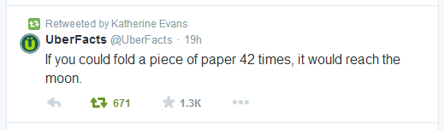
If a piece of paper is 0.004 inches thick (according to Wolframalpha.com) verify this tweet to be true or false. We are 247,739 miles from the Moon.

Hint #1: Use Math!
Hint #2: Fold a piece of paper, if you fold it once, how many sheets of paper are lying on each other? If you fold it again (that would be twice) how many sheets of paper are lying on each other?
Hint #3: Look at the function of folds as the input and sheets of paper as the output to create a sequence. Learn from the sequence.

